**Contents of Zipped file:**

The following extensions are contained in the zipped folder

1. qrcodeaddon
2. bncwebservices
3. bncwebserviceshmc

**Pre-requisites:**

1. Hybris version 5.1
2. Storefront should be up and running preferably, electronic store

**Steps for installation:**

1. Unzip the attached zipped file and place the contained extensions in custom folder of hybris
2. Now perform following command to include and build qrcodeaddon in the project.

*ant addoninstall -Daddonnames="qrcodeaddon" -DaddonStorefront.yacceleratorstorefront="<<storefront name e.g. bncstorefront>>"*

1. Include the following in localextensions.xml file:

<extension name=*"qrcodeaddon"* />

<extension name=*"bncwebservices"* />

<extension name=*"bncwebserviceshmc"* />

In case there is already a **webservices** and **webserviceshmc** extension entry in localextensions.xml, then comment those entries and enter the above.

1. Add the following entry in storefront’s spring-cms-config.xml

<entry key=*"UCOIDOnOrderConfirmationComponent"* value-ref=*"uCOIDOnOrderConfirmationComponentRenderer"*/>

In the following bean entry:

<alias alias=*"cmsComponentRendererRegistry"* name=*"acceleratorCMSComponentRendererRegistry"*/>

<bean id=*"acceleratorCMSComponentRendererRegistry"* parent=*"defaultCMSComponentRendererRegistry"*>

<property name=*"renderers"*>

<map merge=*"true"*>

<entry key=*"CMSLinkComponent"* value-ref=*"cmsLinkComponentRenderer"*/>

<entry key=*"UCOIDOnOrderConfirmationComponent"* value-ref=*"uCOIDOnOrderConfirmationComponentRenderer"*/>

</map>

</property>

</bean>

1. Run ant clean all. This will build the entire project once again including your module extensions.
2. Once the build is successful, start the hybris server using *hybrisserver.bat* command
3. Once the hybris server is started, then system update is required.

Update the hybris Commerce Suite

To finish the installation, you have to update the hybris Commerce Suite. During the update, the database tables, the type system, and the mandatory system data are created for the new addon.

1. Open the hybris Administration Console. The default URL for the hAC is http://localhost:9001.
2. You are prompted to enter a user account and a password.  
   By factory default, you can use the **admin**user account and the **nimda** password.

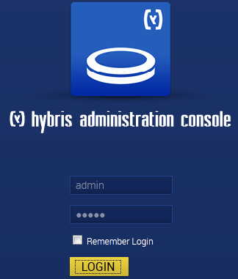

1. Go to the Platform tab and select Update option.

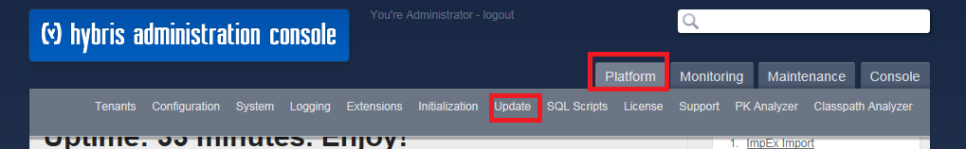

1. The Update page opens with preconfigured settings for update.
2. Deselect the checkbox stating “Create essential data”
3. Select the checkbox next to qrcodeaddon

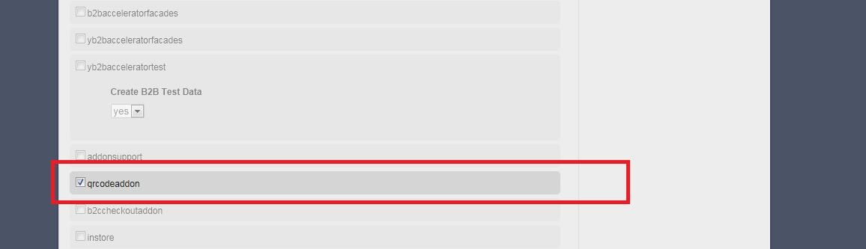

1. Without changing any more settings, click the Update button. The update process starts and can take several minutes.
2. Once update is completed, click on continue button.